**Liverpool Zone By-Laws for Football (Soccer) - Gala Day**

Rules for all sports played within the Zone shall be as for those set down by the State Governing Body for that sport, with the following exceptions:

Conveners have the option to modify rules prior to the season if circumstances are required and if all competing schools agree.

Competition to split between 2 leagues (Green and Yellow) - IF NEEDED. No crossover for finals if this is the format.

# 1. DRESS:

1.1 - Soccer shoes or sports shoes are to be worn.

1.2 - Each team member must be in the same jersey or shirt.

1.3 - Shin pads and long socks are compulsory and must be worn by all players. They must be in good condition. Players without shin pads will not be allowed to play on the field.

# 2. SUPERVISION:

2.1 - Standard teacher Duty of Care applies at all times.

2.2 - Liaise with the other teacher regarding supervision of non- participating students.

2.3 - Remind students to use school toilets before leaving for Gala day fixtures.

2.4 - When direct supervision of students isn't possible (i.e. toilet break during play), ensure students move in groups.

2.5 - Play may be briefly halted where applicable to accompany all students to toilets. This is not possible for all sports.

# 3. EQUIPMENT:

3.1 - Each school must bring to ALL games:

* A fully equipped first aid kit.
* 10 witches hats (for markers of Junior games)
* If available, 4x 2 metre agility poles (to use as goals)
* A size 4 soccer ball (at least one).

3.2 - Each school is responsible for setting up their respective soccer fields upon arriving at the venue.

# 4. VENUES:

4.1 - Each school is responsible for removing all the rubbish from the side of the soccer fields, where they have been sitting, prior to leaving. Schools will be playing at the following grounds throughout the season:

* Hammondville Oval, Ireland park, South park and Ash Road

# 5. SAFETY:

5.1 - All boots are to be checked prior to the game ensuring that studs do not have any sharp edges.

5.2 - Shin pads are compulsory and preferably worn with long socks.

# 6. TEAMS:

6.1 - Seniors – Years 5 and 6 (11 a side plus reserves) Juniors – Years 3 and 4 (11 a side plus reserves). Teams to enter the same number of junior and senior teams.

6.2 - There is no limit to the number of replacements that a team can make during any Liverpool Zone PSSA Football (Soccer) game.

6.4 - Schools fielding multiple teams in the same competition (e.g. two football teams) CAN NOT swap or have players playing in both teams throughout the season. Players MUST play in their selected team. This includes finals.

# 7. DURATION OF MATCHES:

7.1 - Gala Days 3 Matches - 4 schools at 1 ground (2 fields)

Junior (10 minutes per half, 5 minute half time and 5 minute between games):

Game 1 - commences at 10:00

Game 2 - commences at 11:15

Game 3 - commences at 12:30

Senior (15 minutes per half, 5 minute half time and 10 minute between games/to travel to different field):

Game 1 - commences at 10:30

Game 2 - commences at 11:45

Game 3 - commences at 1:00

**Games finish 1:45**

# 8. THE FIELD OF PLAY:

8.1 - Seniors – Full size field

8.2 - Juniors – Either

a) An appropriately sized field already marked or;

b) A field marked out by cones onto a full size field: The goal line runs across the outer edge of the goal keepers box (18 yard box). The sidelines are 10 metres in from the original field’s sideline.

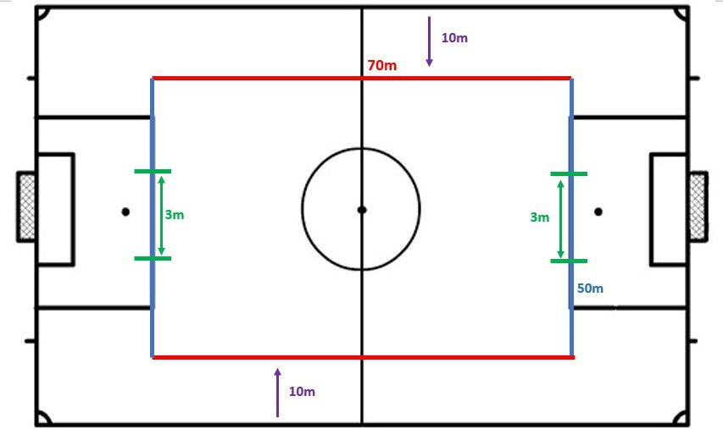

8.3 - Goal size:

Seniors: Full size goal

Juniors: A goal marked out, preferably with agility poles, at a width of 3 metres.

# 9. RULES:

9.1 - A coin is tossed and the team that wins the toss decides which goal it will attack in the first half of the match. The other team takes the kick- off to start the match. The team winning the toss takes the kick-off to start the second half of the match. The teams change ends at half- time.

9.2 - The procedure for a kick-off involves:

* All players are in their half of the field.
* The opponents of the team taking the kick-off are at least 10 meters from the ball until it is in play.
* The ball is stationary on the centre mark.
* The referee gives a signal.
* The ball is in play when it is kicked (any direction)
* The kicker does not kick the ball a second time until it has touched another player.
* If the kicker touches the ball a second time before it has touched another player and indirect kick is awarded to the opposing team, to be taken from the place where the infringement occurred. For any other infringement off the kick-off, the kick-off is retaken.

9.3 - A kick-off is used when:

* Starting a match.
* After a goal has been scored.
* At the start of the second half of the match.
* At the start of each period of extra time, where applicable. A goal may be scored directly from the kick-off.

9.4 - A dropped ball is a method of restarting the match after a temporary stoppage which becomes necessary, while the ball is in play, for any reason not mentioned elsewhere in the laws of the game. The referee drops the ball at the place where it was located when play was stopped. Play restarts when the ball touches the ground. The ball is dropped again if it is touched by a player before it touches the ground.

9.5 - A throw-in is a method of restarting play. A goal cannot be scored directly from a throw-in. A throw-in is awarded:

* When the whole ball passes over the sideline, either in the air or on the ground.
* From the point where it crossed the sideline.
* To the opponents of the player who touched the ball last.

9.6 - At the moment of delivering a throw-in the thrower:

* Faces the field of play.
* Has part of each foot either on the side line or on the ground outside the side line.
* Uses both hands.
* Delivers the ball from behind and over his head.
* The thrower may not touch the ball again until it has touched another player. The ball is in play immediately as it enters the field of play.

9.7 - If, after the ball is in play, the thrower touches the ball a second time before it has touched another player:

* An indirect free kick is awarded to the opposing team, the kick to be taken from the place where the infringement occurred.
* If the thrower throws the ball with one hand only or only has one foot on the ground when throwing the ball:
* The opposing team will then receive the ball for a throw-in.
* For any other infringements of this law the throw-in is taken by a player of the opposing team.

9.8 - Special Circumstances:

* A free kick taken by the defending team inside its own goal area is taken from any point within the goal area.
* An indirect free kick awarded to the attacking team in its opponents’ goal area is taken from the goal area line parallel to the goal line at the point nearest to where the infringement occurred.
* A dropped ball to restart the match after play has been temporarily stopped is taken inside the goal area line parallel to the goal line at the point nearest to where the ball was located when play was stopped.

9. 9 - The ball is out of play when:

* It has wholly crossed the goal line or side line whether on the ground or in the air.
* Play has been stopped by the referee.
* The ball is in play at all other times, including when:
* It rebounds from the goalpost, crossbar or corner flag post and remains in the field of play.
* It rebounds from the referee when on the field of play.

9.10 - In Junior games, referees will not award a goal if they believe the ball has not been kicked within reasonable reach of the upwards arm stretch of a junior goalkeeper **OR** If agility poles are in use: a goal will not be awarded if they believe the ball has been kicked above the height of the agility poles.

9.11 - The team scoring the greater number of goals during the match is the winner. If both teams score an equal number of goals, or if no goals are scored, the match is drawn. Extra time or penalty shoot outs are not permitted. A draw will be awarded in this circumstance.

9.12 - Fouls and misconduct are penalised as follows:

* A direct free kick is awarded to the opposing team if a player commits any of the following offences in a manner considered by a referee to be careless, reckless or using excessive force:
* Kicks or attempts to kick an opponent. Trips or attempts to trip an opponent. Jumps at an opponent.
* Charges an opponent.
* Strikes or attempts to strike an opponent. Pushes an opponent.
* A direct free kick is also awarded to the opposing team if a player commits any of the following offences:
* Tackles an opponent to gain possession of the ball, making contact with the opponent before touching the ball.
* Holds an opponent. Spits at an opponent.
* Handles the ball deliberately (except the goal keeper in his own area).
* A direct free kick is taken from where the offence occurred.

9.13 - A penalty kick is awarded if any of the above 10 offences is committed by a player within his own penalty area, irrespective of the position of the ball, provided it is in play.

9.14 - An indirect free kick is awarded to the opposing team if a goalkeeper, inside his own penalty area, commits any of the following offences:

* Takes more than six seconds while controlling the ball with his hands before releasing it from his possession.
* Touches the ball a second time after it has left his possession before it has touched another player.
* Touches the ball with his hands after it has been deliberately kicked to him by his team mate.
* Wastes time.
* An indirect free kick is also awarded to the opposing team if a player, in the opinion of the referee:
* Plays in a dangerous manner.
* Impedes the progress of another player.
* Prevents the goalkeeper from releasing the ball from his hands. The indirect kick is to be taken from where the offence occurred.

9.15 - A player is in an off-side position if:

* He is nearer his opponents’ goal line than both the ball and the second last opponent.

A player is not in an off-side position if:

* He is in his own half of the field of play or
* He is level with the second last opponent or
* He is level with the last two opponents.

A player in an off-side position is only penalised if, at the moment the ball touches or is played by one of his team, he is, in the opinion of the referee, involved in active play by:

* Interfering with play or
* Interfering with an opponent or
* Gaining an advantage by being in that position.

There is no off-side offence if a player receives the ball directly from:

* A goal kick
* A throw-in
* A corner kick.

For any off-side offence, the referee awards an indirect free kick to the opposing team to be taken from the place where the infringement occurred.

The off-side rule will now apply to junior games.

9.16 - Points will be awarded as follows:

Win = (3) three points

Draw = (2) two points

Loss = (1) one point

Forfeit Loss = (0) zero points

Washed-out games (a field at the venue is unavailable) - if not made up at the end of the season in the draw, will be awarded as (3) three points to each team.

9.17 - All results are to be emailed to the convenor by the following Monday after the round has been completed (on Friday if possible). It is the responsibility of both teams to send the results.

9.18 - Penalties

Penalties for ALL finals (Semi and Grand) - Gala Day #4

If after full time the game is a draw the game will go to penalties being a best of 5. More penalties can be taken after this point to determine the winning team if no result after 5. Conditions for penalties:

* The goalie can NOT be swapped after the full time whistle to take place for penalties.
* ONLY players that were on the field can take penalties (not sub players)
* After the game; each team are given 5 minutes to organise the order of kicks
* Goal keepers must stay on line
* The ball must be stationary
* Teams stay at halfway/with the coach on the sideline.
* The penalty kick ends when the ball stops moving or goes out of play
* Kicker must not stop during kick (consistent movement)
* No following up after the kick is taken
* Penalty to be taken 11m from the goal line

# 10. FINALS

Standings are based on win percentage not points.

Top 6 make finals for both leagues (Green/Yellow)

* There will be 1 overall winner for both leagues.

10.1 - 1st and 2nd place rest

Game 1

Lower Semi 1 - 3rd Vs 6th

Lower Semi 2 - 4th Vs 5th

Games 2

Winners Semi 1 - 1st Vs Winner of Semi 2

Winners Semi 2 - 2nd Vs Winner of Semi 1

Games 3

Grand Final - Winner of Winner Semi 1 Vs Winner of Winner Semi 2