AFL BY-LAWS – Liverpool Zone PSSA
Rules for all sports played within the Zone shall be as for those set down by the State Governing Body for that sport, with the following exception:
- Conveners have the option to modify rules prior to the season if circumstances be required and if all competing schools agree.
1. DRESS
  - Running shoes or football boots (plastic studs only) are allowed.
1.2 Players are not to wear any item of jewellery.
2. SUPERVISION
2.1 Standard teacher Duty of Care applies at all times and for all teachers regardless of the school that teacher attends.

2.2 Liaise with the other teacher regarding supervision of non-participating students. It is the responsibility of any teacher not refereeing to supervise students from both schools competing.

2.3 Remind students to use school toilets before leaving for PSSA fixtures.

2.4 When direct supervision of students isn't possible (i.e. toilet break during play), ensure students move in groups.

2.5 Play may be briefly halted where applicable to accompany all students to toilets. This is not possible for all sports.

3. EQUIPMENT
3.1 Size 3 synthetic football
4. VENUES
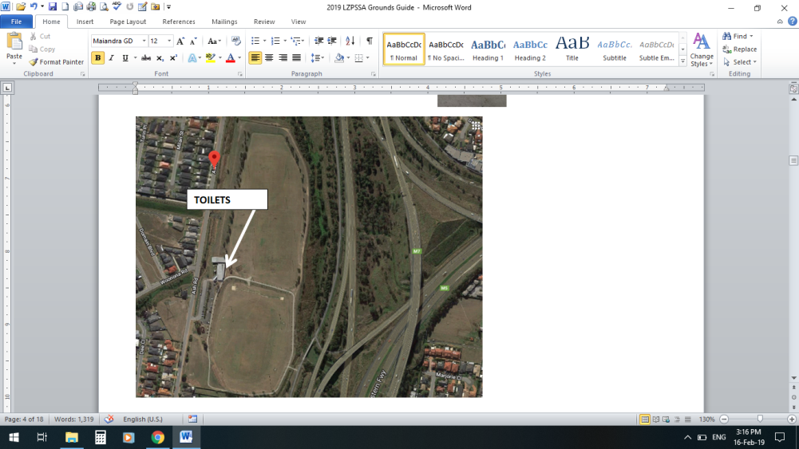  4.2 – ASH RD PRESTONS | 4.1 - PETER MILLAR PARK CASULA  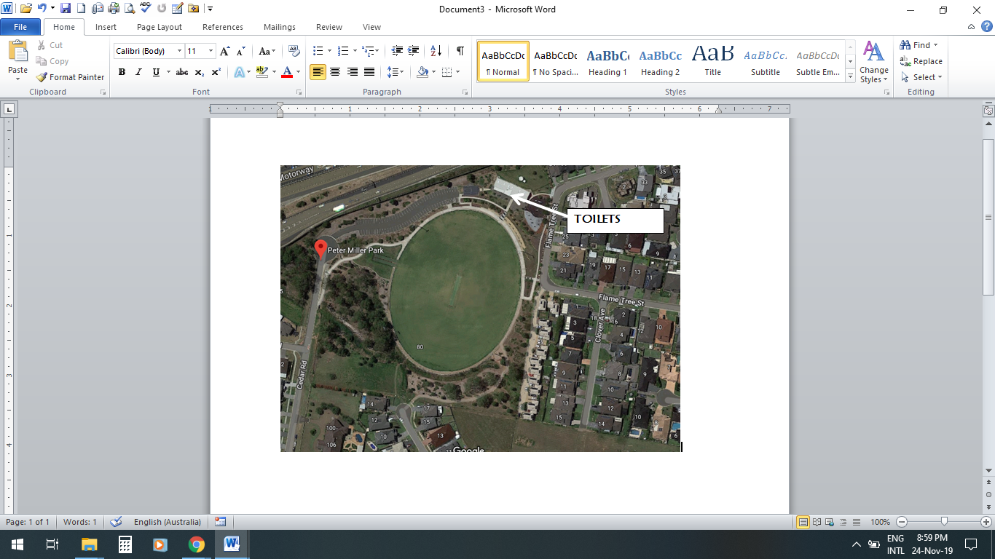
4.3 Modified ground to be used. Minimum size of ground to be 75m x 40m. Each zone (marked by cones) to be approximately one third of the ground.
5. SAFETY
5.1 All students, in accordance with the Liverpool Zone PSSA Sun Safety Rules, must wear a hat to and from the venue and when not playing a match.
5.2 All students must be sitting down in their designated area when not playing a match.

5.3 ALL PLAYERS MUST WEAR A MOUTHGUARD TO TAKE THE FIELD. PLAYERS WITHOUT MOUTHGUARD WILL NOT BE ALLOWED TO PLAY.

5.4 Coaches are not permitted on the ground during play unless attending to an injury.

6. TEAMS
6.1 JUNIORS - Years 3 and 4 ONLY: Teams shall consist of 9 players, 6 boys and 3 girls on the field at any one time with any number of reserves.
SENIORS – Years 5 and 6 ONLY: Teams shall consist of 9 players, 6 boys and 3 girls on the field at any one time with any number of reserves.
6.2 The team will be divided into three even positions (i.e. a team of 9 will have 3 forwards, 3 centres and 3 backs).
6.3 Girls will play in a “Girl Only Zone”, which will rotate throughout each of the three sections of the field, MID ZONE, FORWARD ZONE and BACK ZONE. Ie Girls from both teams will only paly against each other. Games will begin with the girls zone being in the MID ZONE.
6.4 Juniors: Players are to remain in nominated position in each Third of the field for the entire period of play.
Seniors: Players are to begin in nominated position within each third of the field. Once ball-up has taken place (at the start of the game/ or after a goal), players may move out of zone but only approximately 5 metres.
6.5 Players may change position in each break at the coaches discretion.
6.6 In the interests of fairness and safety Year 3 and 4 students ONLY may play in Junior games and Year 5 and 6 students ONLY may play in Senior games. If players are playing in the wrong level for their age/grade this will result in instant disqualification.
6.7 Each team member must play one half minimum each week.
6.8 Schools fielding multiple teams in the same competition (e.g. two AFL teams) will have the first two weeks of the season to finalise their sides. From Week 3 of that season onwards, students must remain in their chosen side and cannot move between ‘A’ and ‘B’ teams. This also includes any finals that a team may have qualified for.

7. DURATION OF MATCHES
7.1 3 thirds of:
Juniors: 10 minutes
Seniors: 12 minutes

IN-GAME RULES
8. START OF PLAY
8.1 The game shall be started by a ball-up (and restarted after each goal) between two players in the centre of the ground. Players contesting the ball-up should be of similar size and will be rotated.
8.2 A Player may not grab the ball at the ball-up and play on. He must tap the ball and cannot play the ball again until another player has touched it.
8.3 Players to stay within their zones until the ball-up.
9. OUT OF BOUNDS
9.1 When the ball goes out of bounds a free kick is awarded against the team to last touch the ball. A player cannot kick for goal from an out of bounds free kick. If the umpire cannot determine which team last touched the ball then play will be restarted by a ball up from where the ball went out of bounds.
10. TACKLING (JUNIORS)
10.1 Players can: ‘Hold and then Release’ an opposition player who is in possession of the ball by grabbing the player with one or two hands between the knees and the shoulder. No bumping, slinging, or brining a player to ground is allowed.
10.2 There is to be only one person making the tackle.
10.3 If the player is held, without having a prior opportunity to dispose of the ball, the umpire will shout ‘release’. The tackler must then release the opposition player, who has 3 seconds to dispose of the ball. If a player has had prior opportunity to dispose of the ball and is held, or if they do not dispose of the ball in the 3 seconds after ‘release’ the tackler will be rewarded with a free kick
10. Cont. TACKLING (SENIORS)
10.4 Players can: Hold or bear hug an opponent in possession of the ball with their hands between the shoulder and knees only
10.5 Players can: Knock or steal the ball from an opponent’s hands.
10.6 Players can: Sheppard (no rough shepparding allowed)
10.7 If a player has had prior opportunity to dispose of the ball and is tackled without disposing of the ball, the tackler will be rewarded with a free kick. NB: Umpires can award a free kick against a tackle that is considered unnecessarily rough.
10.8 All players cannot:
a. Throw another player to the ground
B. Push the opponent in the back

11. MARK
11.1 A free kick is awarded to any player who fairly catches a kick providing the kick travels approximately ten meters.
12. BOUNCING THE BALL
12.1 A Player in possession of and running with the ball is permitted to bounce the ball once only before kicking or handballing. A player must bounce or tap the ball on the ground the ball every 10 meters.
13. KICKING THE BALL OFF THE GROUND
13.1 Players are not permitted to deliberately kick the ball off the ground.
14. BALL TRANSITION
14.1 The ball must be touched by a different player in each zone.
15. SCORING
15.1 A goal (6 points) is awarded when the ball is kicked between the two major posts
15.2 If the ball is touched before passing the two major posts or passes between the minor and major posts, 1 point is awarded.
15.3 After a goal is scored play restarts with a ball-up in the centre. After a point is scored play restarts with a kick from the defending team from between the two major posts.
15.4 Goals can only be scored by forwards (who are designated by a bib) within their team’s forward zone. Scores from other positions or from outside the forward zone do not count and then a ball-up takes place from the place the kick was taken. Forwards are able to score if they mark the ball inside their zone but shoot from outside.
16. ORDER OFF RULE
16.1 Players may be ordered from the field for rough play or abusive language. Time period is left to the umpire’s discretion.
17. END OF MATCH
17.1 Players to shake hands with the opposition team.

